Enhancement of Flow-R algorithms and usage for multiple gravitational hazards at a regional scale

Pascal Horton (1), Clément Michoud (1), Thierry Oppikoffer (2), Benoit Mazzoti (3), Michel Jaboyedoff (4)

1. Terranum Sàrl, Bussigny, Switzerland
2. Geological Survey of Norway, Trondheim, Norway
3. Service des forêts et de la faune, Fribourg, Switzerland
4. Institute of Earth Sciences, University of Lausanne, Lausanne, Switzerland

Table of Contents

2 Introduction 1

3 Case studies and data 1

3.1 Fribourg Prealps 1

3.2 Norway 1

4 Debris-flows: multi-parameter approach 4

4.1 Objectives 4

4.2 Recommended multi-parameter approach 4

4.3 Results 4

4.4 Discussion 4

5 Snow avalanches: event-based calibration 4

5.1 Objectives 4

5.2 Recommended event-based approach 4

5.3 Results 4

5.4 Discussion 4

6 Rockfall: variable reach angle 4

6.1 Objectives 4

6.2 New propagation algorithm 4

6.3 Results 4

6.4 Discussion 4

7 Rock avalanches: simple propagation assessment 5

7.1 Objectives 5

7.2 New inertial algorithm 6

7.3 Results 7

7.3.1 Energy algorithm 7

7.3.2 Effect of the opening angle 9

7.3.3 Effect of the memory length 14

7.4 Discussion 14

8 Conclusions 14

# Introduction

# Case studies and data

## Fribourg Prealps

## Norway

We were provided with 2 case study areas in Norway. It is important to note here that the available DEM (10 m resolution) is the post-event topography. Thus, neither the source areas topography, nor the deposition zone, corresponds to the actual conditions where the rock avalanches took place. In our modelling, the propagation must spread over the former deposit. It is thus likely that the parameterization needed to cover the observed event would result in an over-estimated runout modelling.

For both case studies, we outlined the observed propagation area and the corresponding source area. It is a rough estimation based on the provided orthophoto, the hillshade, and advices from Thierry Oppikofer. Moreover, the delineation represents the denser part of the propagation, without taking into account isolated blocks that diverged from the mass. Another difficulty was to distinguish the blocks from other source areas or even from the opposite slope without a better knowledge of the case studies. For better assessment, higher resolution data and field work would be required.

The first case study is the rock avalanche of **Urdbouri** nearby Arabygdi. Figure 1 illustrates the estimated propagation area on the orthophotograph and Figure 2 on the hillshade.

The second case study is the rock avalanche nearby **Langvatnet** lake (Fræna municipality). Figure 3 illustrates the estimated propagation area on the orthophotograph and Figure 4 on the hillshade.

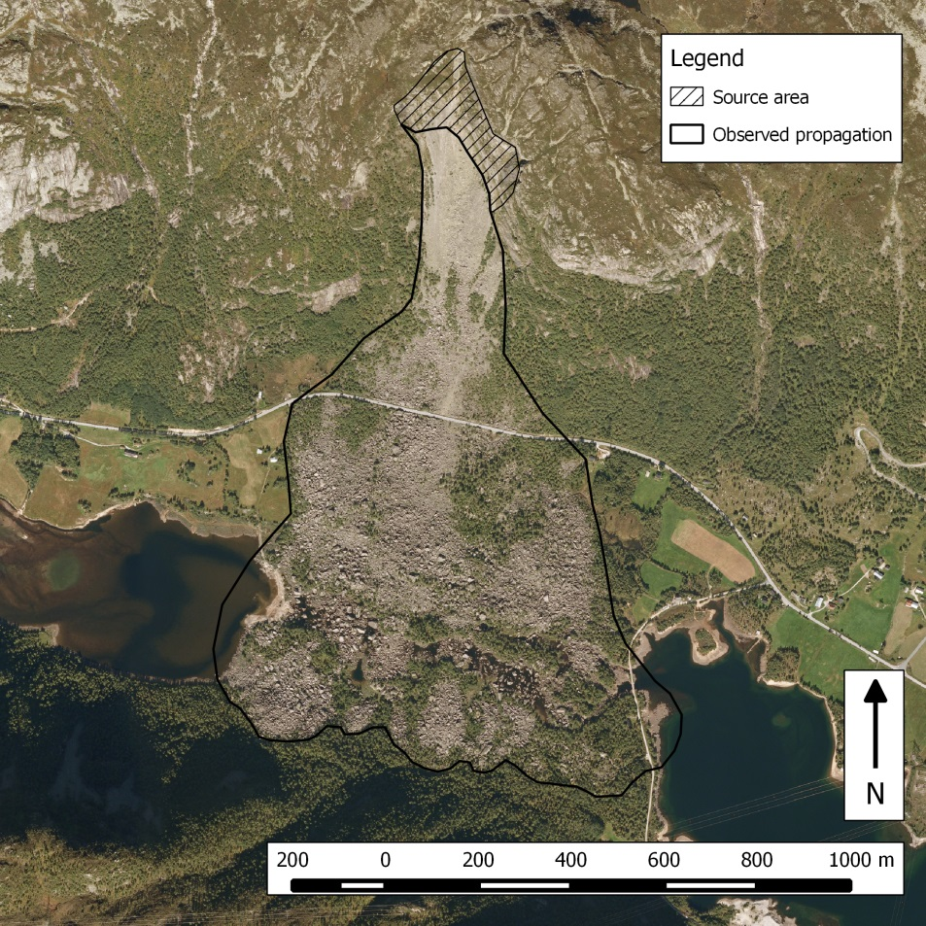

Figure 1. The Urdbouri case study orthophoto with the estimated outline of the observed event.

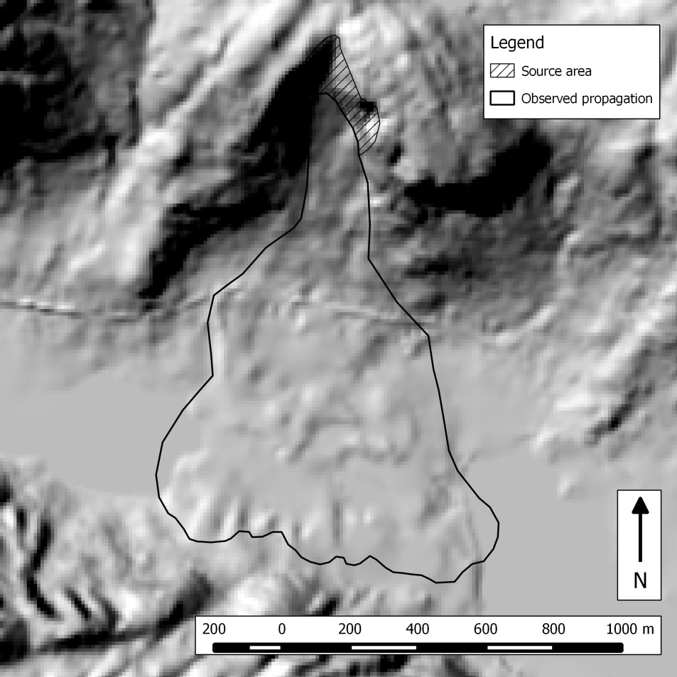

Figure 2. The Urdbouri case study hillshade with the estimated outline of the observed event.

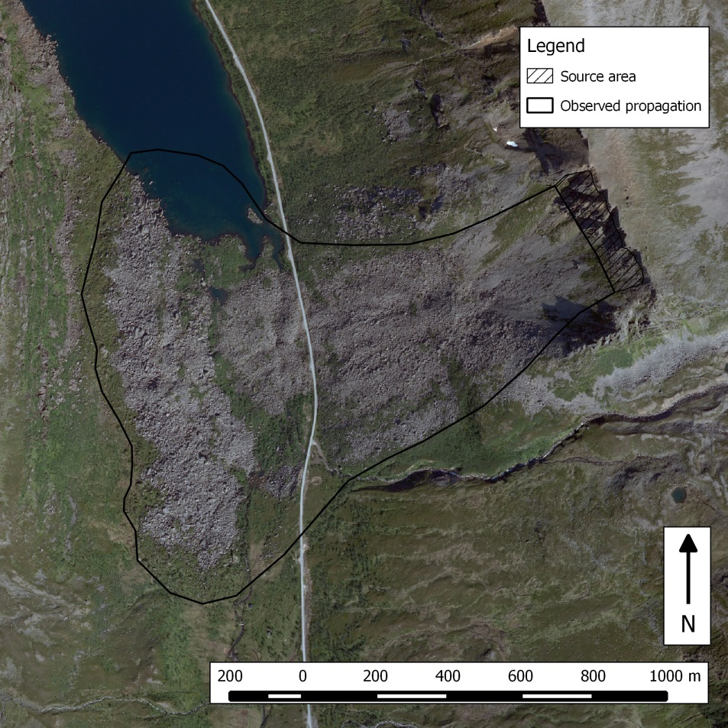

Figure 3. The Langvatnet case study orthophoto with the estimated outline of the observed event.

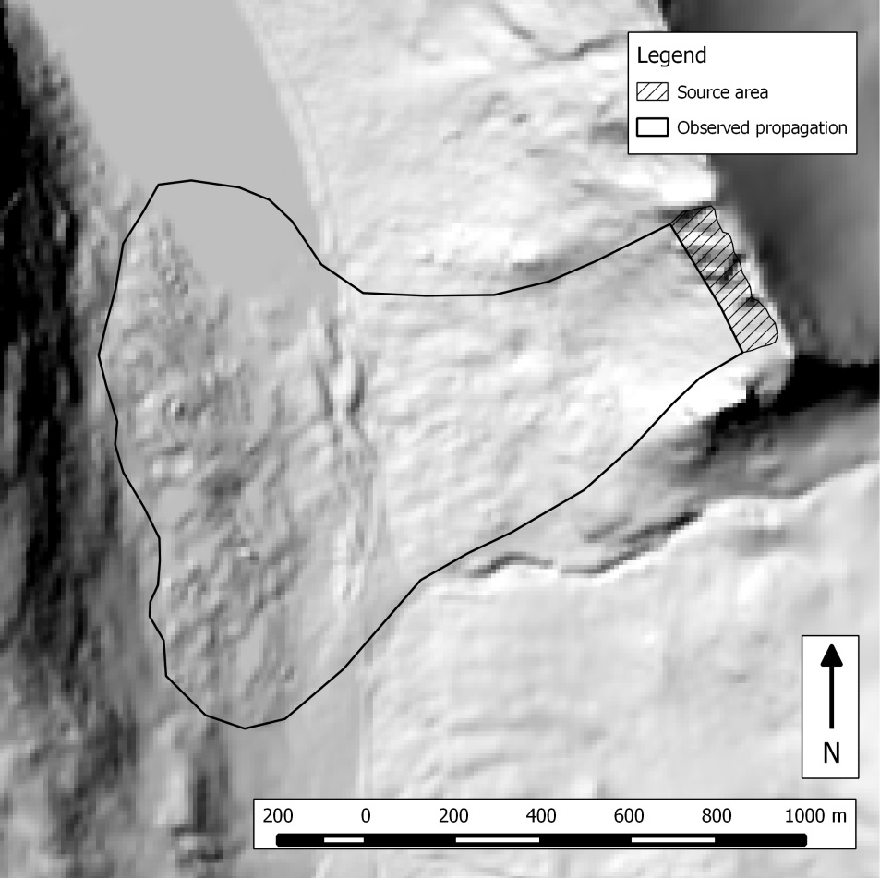

Figure 4. The Langvatnet case study hillshade with the estimated outline of the observed event.

# Debris-flows: multi-parameter approach

## Objectives

## Recommended multi-parameter approach

Au vu du manque d’événements observés dans les Préalpes fribrougeoises, la paramétrisation de la propagation des laves torrentielles s’appuie sur des valeurs issues de la littérature (Table 2). Il a été décidé lors de la séance intermédiaire d’ignorer les cartes de dangers existantes, ainsi que les événements reportés dans StorME, dont la nature est discutable.

Table 2. Valeurs de paramètres de propagations issus de la littérature :

|  |  |  |  |
| --- | --- | --- | --- |
| Référence | Lieu | Exp. Holmgren | Angle SFLM |
| Park et al., 2013a | Corée | 4 | 13° |
| Park et al., 2013b | Corée | 4 | 11° |
| Fischer et al., 2012 | Norvège |  | 11° |
| Jaboyedoff et al., 2008 | Suisse (VD) | 4 | 11° |
| Michoud et al., 2010 | Suisse (Bagnes) | 6 |  |
| Horton et al., 2009 | Pakistan | 6 |  |
| Baumann et al., 2011 | Argentine | 4 |  |
| Huggel et al., 2002 | Alpes EU & Canada |  | 11° |
| Zimmermann et al., 1997 | Suisse (Alpes) |  | 11° * |
| Bathurst et al., 1997 | Japon |  | 11° |
| Rickenmann & Zimm., 1993 | Suisse (Alpes) |  | 11° |
| Lari et al., 2011 | Italie | 9-10 | 5-15° ** |
| Blahut et al., 2010 | Italie | 5 | 10° |

* pour une granulométrie moyenne à élevée ** avec un contenu en eau important

Nous avons effectué 9 paramétrisations différentes (croisement de 3 paramétrisations pour l’étalement latéral et 3 pour le modèle de friction), plus ou moins pessimistes, afin de fournir une information sur la plausibilité des périmètres proposés et de leur sensibilité aux para-mètres. Le MNT est dégradé à 10 m, (résolution suffisante pour ce type d’approche, Horton et al. 2013).

Calibration de l’étalement

Au vu des valeurs utilisées dans la littérature, nous avons choisi les valeurs suivantes pour l’exposant d’Holmgren (contrôle de l’étalement, cf. chapitre 2.2.2) : 2 – 4 – 6. Une gamme plus large ne semble pas nécessaire, et une gamme plus étroite ne présente pas de variations signifi-catives. Cette sélection est centrée sur 4, étant un exposant d’Holmgren souvent utilisée pour la modélisation des laves torrentielles (voir Table 2). Les Figures 4 et 5 de l’annexe illustrent l’effet de ce paramètre sur l’étalement latéral.

Calibration de la distance de propagation

Un angle d’atteinte de 11° est très souvent utilisé dans différentes études (voir Table 2). A nou-veau, nous avons centré la gamme sur cet angle et considérons les valeurs suivantes : 9° - 11° - 13°. Au regard des valeurs de la littérature, il n’est pas sensé de considérer des valeurs plus ex-trêmes. Les Figures 6 et 7 de l’annexe illustrent 5 valeurs de cet angle de propagation.

## Results

Nous avons donc classé les zones sources en 4 classes différentes (voir Figure 5) selon la présence d’un cours d’eau (d’après GesReau) et selon la relation entre la pente et la surface contributive, considérée pour les événements rares (plus fréquents) ou extrêmes (moins fréquents):

|  |  |
| --- | --- |
| Susceptibilité | Critères |
| Faible | Hors d’un cours d’eau & pour événements extrêmes |
| Moyenne | Hors d’un cours d’eau & pour événements rares |
| Elevée | Dans un cours d’eau & pour événements extrêmes |
| Très élevée | Dans un cours d’eau & pour événements rares |

Les simulations de propagation ont été effectuées pour chacune des 4 classes de zones sources, avec les 9 variantes de paramétrisations de la propagation (3 exposants Holmgren x 3 angles SFLM), ce qui résulte en 36 modélisations de propagations. Celles-ci ont été synthétisées sur 2 cartes : une pour les laves torrentielles dans les cours d’eau permanents (Table 3, voir Figure 6), et une autre carte pour celles en dehors des cours d’eau (Table 4, voir Figure 7). Ces deux cartes sont à considérer séparément, car elles ont chacune leur échelle de susceptibilité propre. Pour chacune de ces cartes, la susceptibilité a été attribuée en prenant en compte les critères des zones sources et le nombre de superficies recouvrantes issues de différentes paramétrisations.

Table 3. Attribution des susceptibilités en fonction de la classe de la zone source et du nombre de propagations recouvrantes pour les laves torrentielles **dans les cours d’eau**.

|  |  |  |
| --- | --- | --- |
| Susceptibilité | Sources | Nombre de propagations |
| Très élevée | Classe 4 (év. rares) | ≥5/9 |
| Élevée | Classe 4 (év. rares) | ≤4/9 |
| Moyenne | Classe 3 (év. extrêmes) | ≥5/9 |
| Faible | Classe 3 (év. extrêmes) | ≤4/9 |

Table 4. Attribution des susceptibilités en fonction de la classe de la zone source et du nombre de propagations recouvrantes pour les laves torrentielles **hors des cours d’eau**.

|  |  |  |
| --- | --- | --- |
| Susceptibilité | Sources | Nombre de propagations |
| Très élevée | Classe 2 (év. rares) | ≥5/9 |
| Élevée | Classe 2 (év. rares) | ≤4/9 |
| Moyenne | Classe 1 (év. extrêmes) | ≥5/9 |
| Faible | Classe 1 (év. extrêmes) | ≤4/9 |

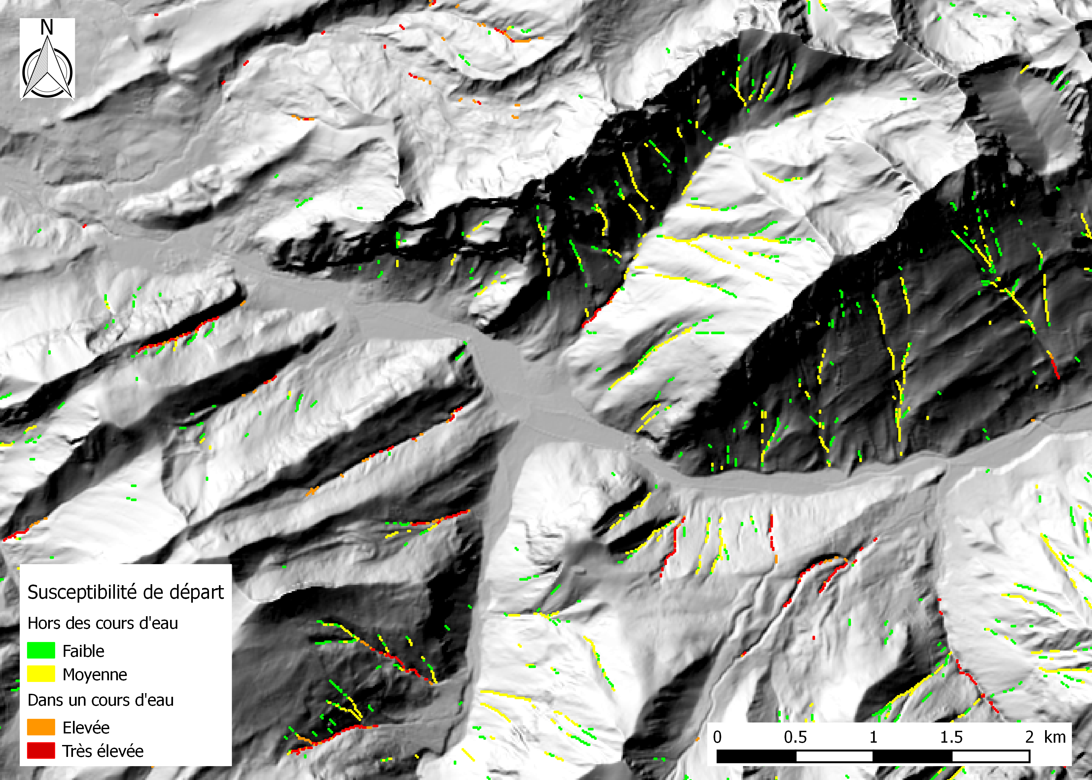

Figure 5. Illustration des zones sources potentielles de laves torrentielles, avec classification en 4 classes

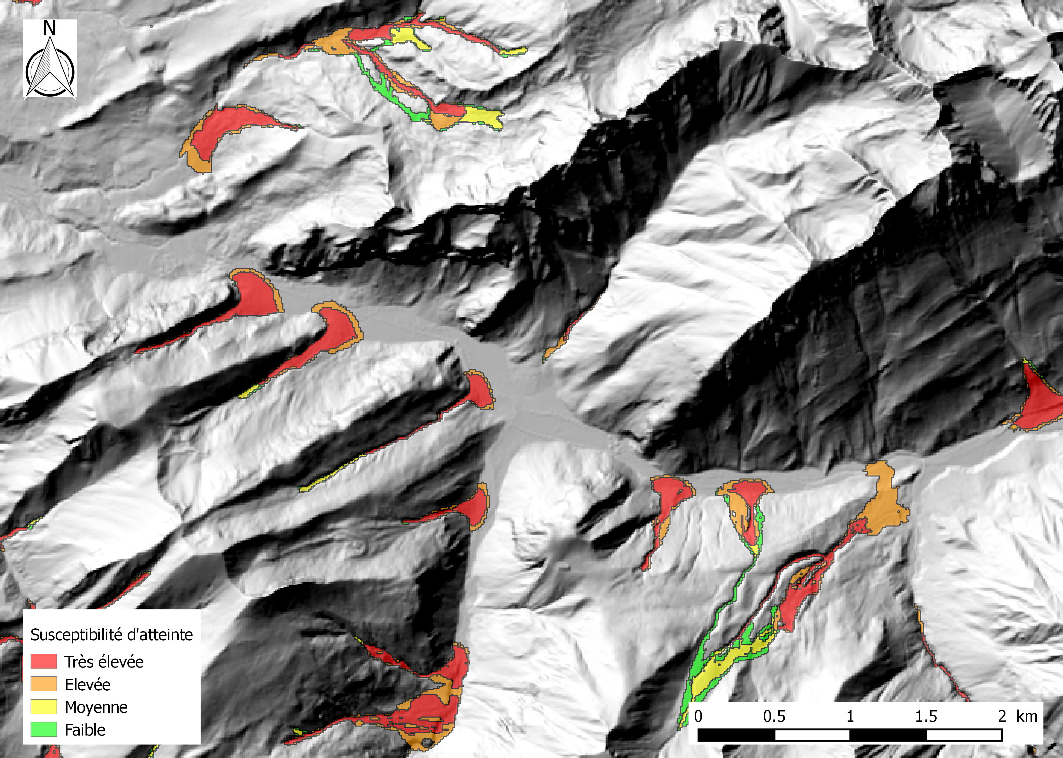

Figure 6. Exemple de la cartographie de la susceptibilité aux laves torrentielles dans les cours d’eau

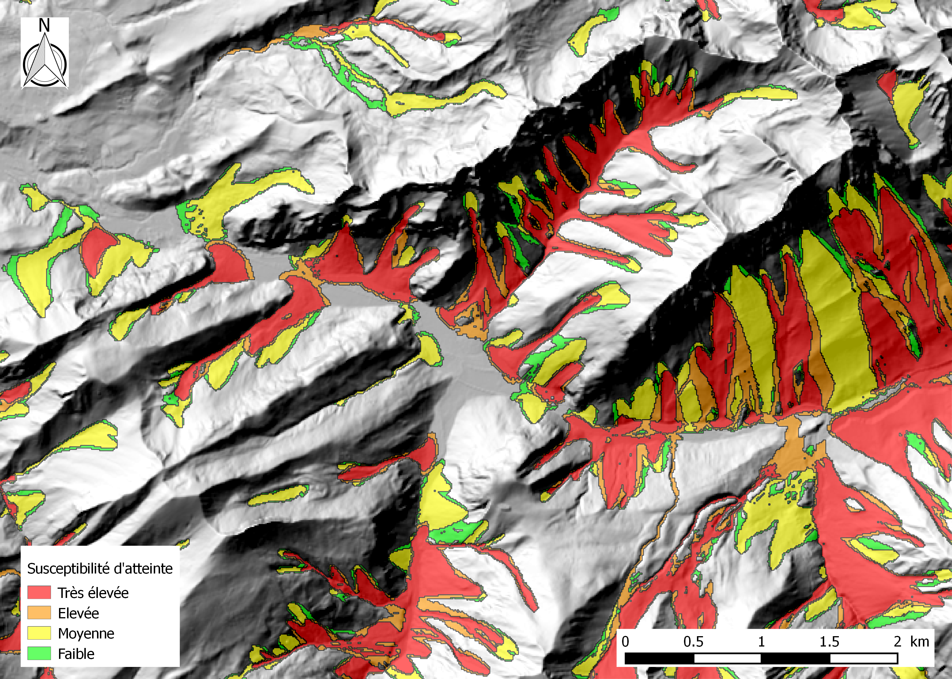

Figure 7. Exemple de la cartographie de la susceptibilité aux laves torrentielles hors des cours d’eau

## Discussion

# Snow avalanches: event-based calibration

## Objectives

## Recommended event-based approach

## Results

## Discussion

# Rockfall: variable reach angle

## Objectives

## New propagation algorithm

## Results

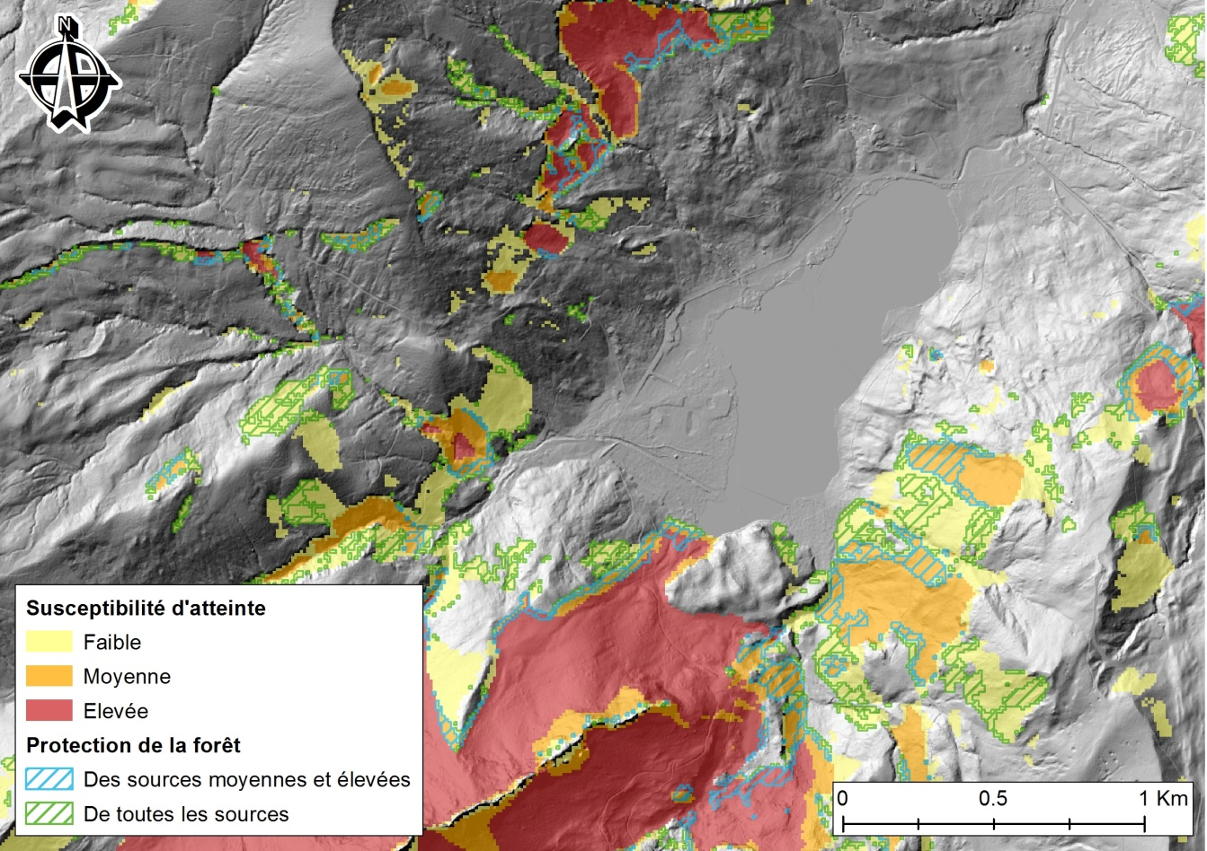

Figure 18: Périmètres indicatifs d’atteinte par des chutes de blocs, autours du Schwarsee.

## Discussion

# Rock avalanches: simple propagation assessment

## Objectives

The Geological Survey of Norway needs to process regional assessments of susceptibility to rock avalanches. Some previous tests with Flow-R showed a certain potential, but the propagations were too much constrained by the topography and could not run-up on opposite slopes. In order to use Flow-R for the assessment of the regional susceptibility to rock avalanches, some modifications were requested. The goal of this project is thus to implement new algorithms in Flow-R to allow a delineation of some observed events.

Flow-R is a model that is designed for simple assessment of the susceptibility to debris flows. Some features of the model can be modified, when others are tied to the global methodology, and thus cannot change.

The issue in the present version is that the propagations of rock avalanches do not run-up on opposite slopes, but flow down the valley as would do a flood-like phenomena. The objective of the present work is thus to implement a more persistent inertia in the propagations in order to account for the velocity direction and not only the topography.

On the other side, Flow-R is not an event-based model, and this cannot be changed (Horton et al, 2013). Thus, Flow-R does not account for the mass. It means that the complex behaviour of the interactions of rocks in an avalanche cannot be assessed by physical algorithms, but can only be mimicked by an empirical approach.

Before implementing any modification in Flow-R, we also tried to parameterize the propagation behaviour in order to get as close as possible to the observed extent. The objective was to reproduce the following behaviours:

* Decreasing of the influence of the very local topography by reducing the terrain roughness.
* Reduction of the lateral spreading in order to keep the rocks rather aggregated and to limit the effect of the topography.
* Increase of the inertia to let the propagation have a run-up behaviour on the opposite slope.

The desired behaviours involved the following actions on the parameters:

* Reduction of the terrain roughness: usage of the modified version of Holmgren’s algorithm with a significant value of *dh*. (see Horton et al., 2013)
* Reduction of the spreading: increase in the exponent value of Holmgren’s algorithm.
* Increase of the inertia: use of more extreme values in the weighting of the directions (persistence).

Because of unsatisfying results, the results obtained with the classic version of Flow-R are only shortly described here. We illustrate the problems encountered with two results obtained using the modified version of Holmgren’s algorithm (exp = 4 and dh = 10 m; we tried with dh up to 70 m), a travel angle of 15°. The original inertia algorithm was first used with the default weighting (Figure 5), and then with the cosines weighting (Figure 6). The main issues are:

* Whatever the values of the parameters (on large ranges), the flow was always mainly influenced by the topography. The propagations were always turning at the bottom of the valleys in order to follow the slope (Figure 5Figure 6 and Figure 6). There was no significant propagation going on the opposite slope.
* In order to send a portion of the propagation in the direction of the opposite slope, we needed to drastically reduce the value of the dispersion in the inertia. This resulted in straight and non-robust trajectories that were often inconsistent. We could observe artefacts related to numerical effects of the grid.

Parameterization of existing algorithms in Flow-R cannot reproduce the behaviour of rock avalanches, mainly the run-up on the opposite slope. There is no choice but implementing a new approach in Flow-R in order to assess the areas susceptible to rock avalanches.

## New inertial algorithm

The required modifications in Flow-R need to reproduce behaviours that are different from a flow mainly constrained by the topography. The propagation should be both controlled by the topography and the inertia, in order to reproduce a run-up behaviour on the opposite slope. In this application, the inertia must have a more important role that it use to have up to now, and it must be more elaborate than a simple weighting (persistence). Flow-R is empirical by nature and thus the provided solution must also be empirical. It cannot involve much physics, as these properties are not available in our case.

We aimed at implementing an empirical algorithm with a minimum of parameters, in order to keep it simple and understandable. We finally introduced an inertia algorithm that is closer to the notion of inertia than the weighting from the persistence. In our previous tests, we observed that the direction is quickly changing for the propagating cells, due to spreading. This resulted in disparate trajectories providing an inconsistent zoning. On the other side, forcing all propagating cells to go in a similar direction also resulted in inappropriate propagations. Our idea here was to keep the freedom for eve-ry propagating cell to follow its own direction, but in the same time, to make it more constant. We tried to mimic the inertia, by introducing a “memory” of the former directions of the propagating cell. It means that every propagating cell has its own history. The average of these former directions then defines the inertia of the propagating cell.

There are 2 parameters for this algorithm:

* The memory length: it is the distance on which we keep the “history” of the directions. It is expressed in number of cells instead of an accurate distance, because it doesn’t take into account the difference in distance between adjacent cells and diagonals. The memory length has a direct influence on how fast the propagating cells can change in direction. A long memory will make the propagating direction more persistent that a short one. The longer the memory, the higher the persistence. Before this memory distance is reached, the influence of the inertia is proportional to the ratio of the actual distance and the memory length: at the propagation start, the inertia is unitary in every direction; the more the cell propagates, the more the inertia is weighted in the forward direction up to the memory is full. It means that the memory length must not be too long: it must not be longer that the hillslope of the rock avalanche. Other-wise, the propagating cells may start to diverge in the valley bottom before the inertia fully takes place.
* The opening angle: it is the angle on which the inertia values are distributed. The higher the opening angle, the wider the spreading area. It must not be be-low 90° neither higher than 315°. This angle is expressed as the total angle: an opening angle of 180° corresponds to ±90°.

Every time a cell is propagated, the following steps are processed:

1. the average of the direction components is processed on the whole memory length,
2. the angle (regarding the North) of this mean direction is evaluated (Figure 7),
3. a triangle with a base equal to the opening angle is centred on this direction (Figure 8),
4. this triangle is split in between the different quadrants so that the area in each quadrant corresponds to its weighting (inertia).

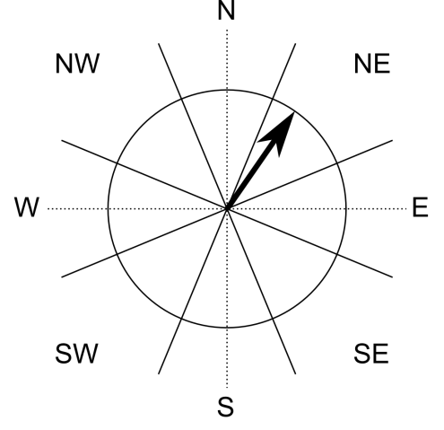

Figure 7. Illustration of the direction angle (average of historical directions) for a propagating cell,   
with the quadrants corresponding to the surrounding cells.

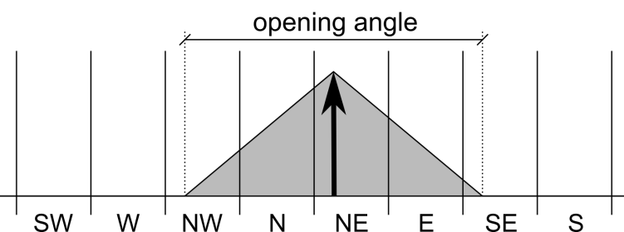

Figure 8. Illustration of the opening angle (here 180°) and the distribution   
of the weights between the quadrants.

## Results

### Energy algorithm

The first parameters to be evaluated are the ones related to the energy calculation. Based on the strategy chosen at the NGU, we will consider the travel angle approach for this study. In this application, we do not set a velocity limit, but consider the approach as a pure Farböschung application. We use here Holmgren’s modified algorithm with a *dh* of 50 m and an exponent of 1, and the new inertia algorithm with an opening angle of 180° and a memory length of 40 (Urdbouri) or 50 cells (Langvatnet).

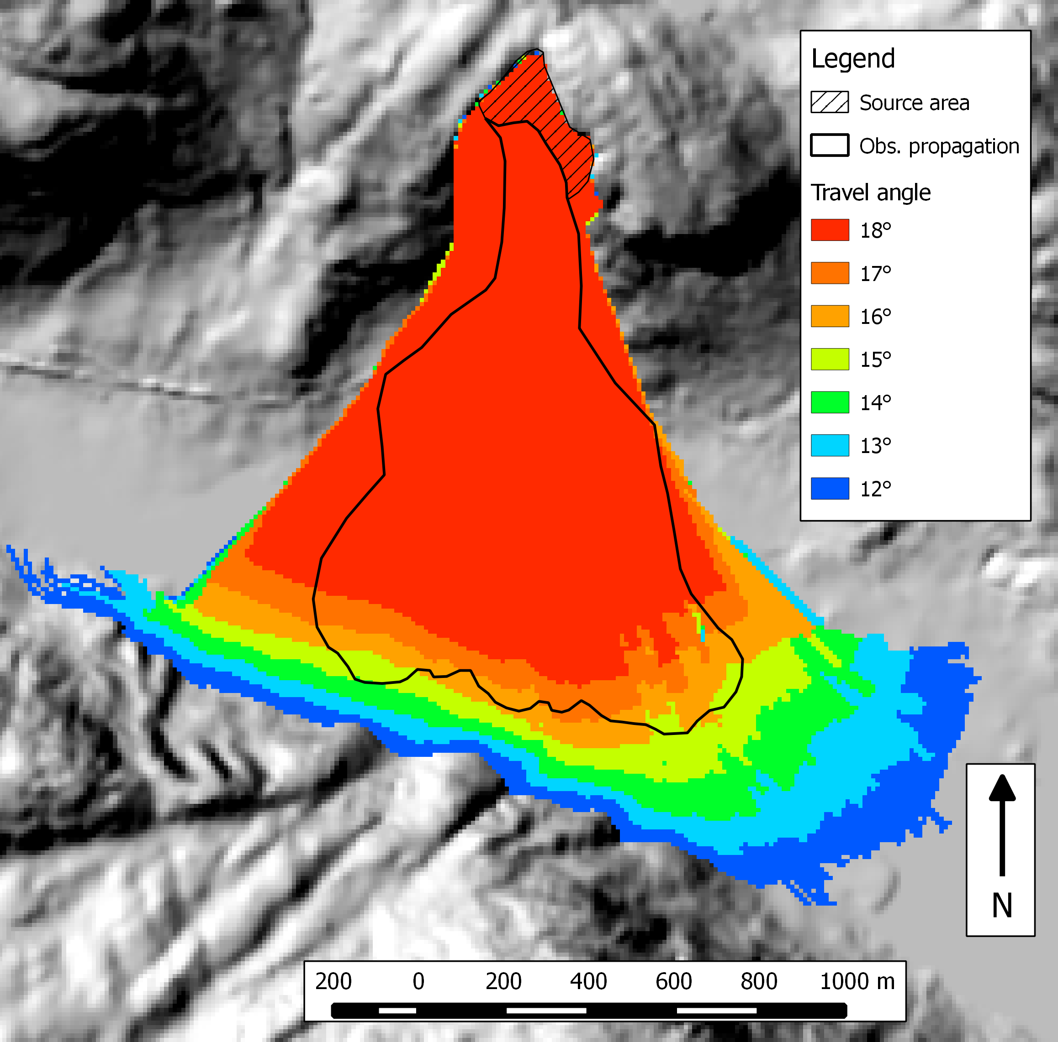

Figure 9. Impact of the travel angle value on the Urdbouri case study.

As one can see in Figure 9 and Figure 10, a travel angle of 15° seems a reasonable choice for both the Urdbouri and the Langvatnet case studies. One has to keep in mind that, as explained in chapter 1.2, the runout distance may be overestimated here due to the post-event topography that we are using. Indeed, the propagation needs to run over significant deposits.

Moreover, this value of 15° does not intend to be generalizable for other case studies. Indeed, as demonstrated in Scheidegger (1973) and Corominas (1996), amongst others, the travel angle is expected to be related to the volume of rocks. As this volume cannot be exactly known in advance, a possible approach would be to consider 3 values: a minimum, a medium and a high volume, and the corresponding travel angles, and to proceed to 3 simulations.

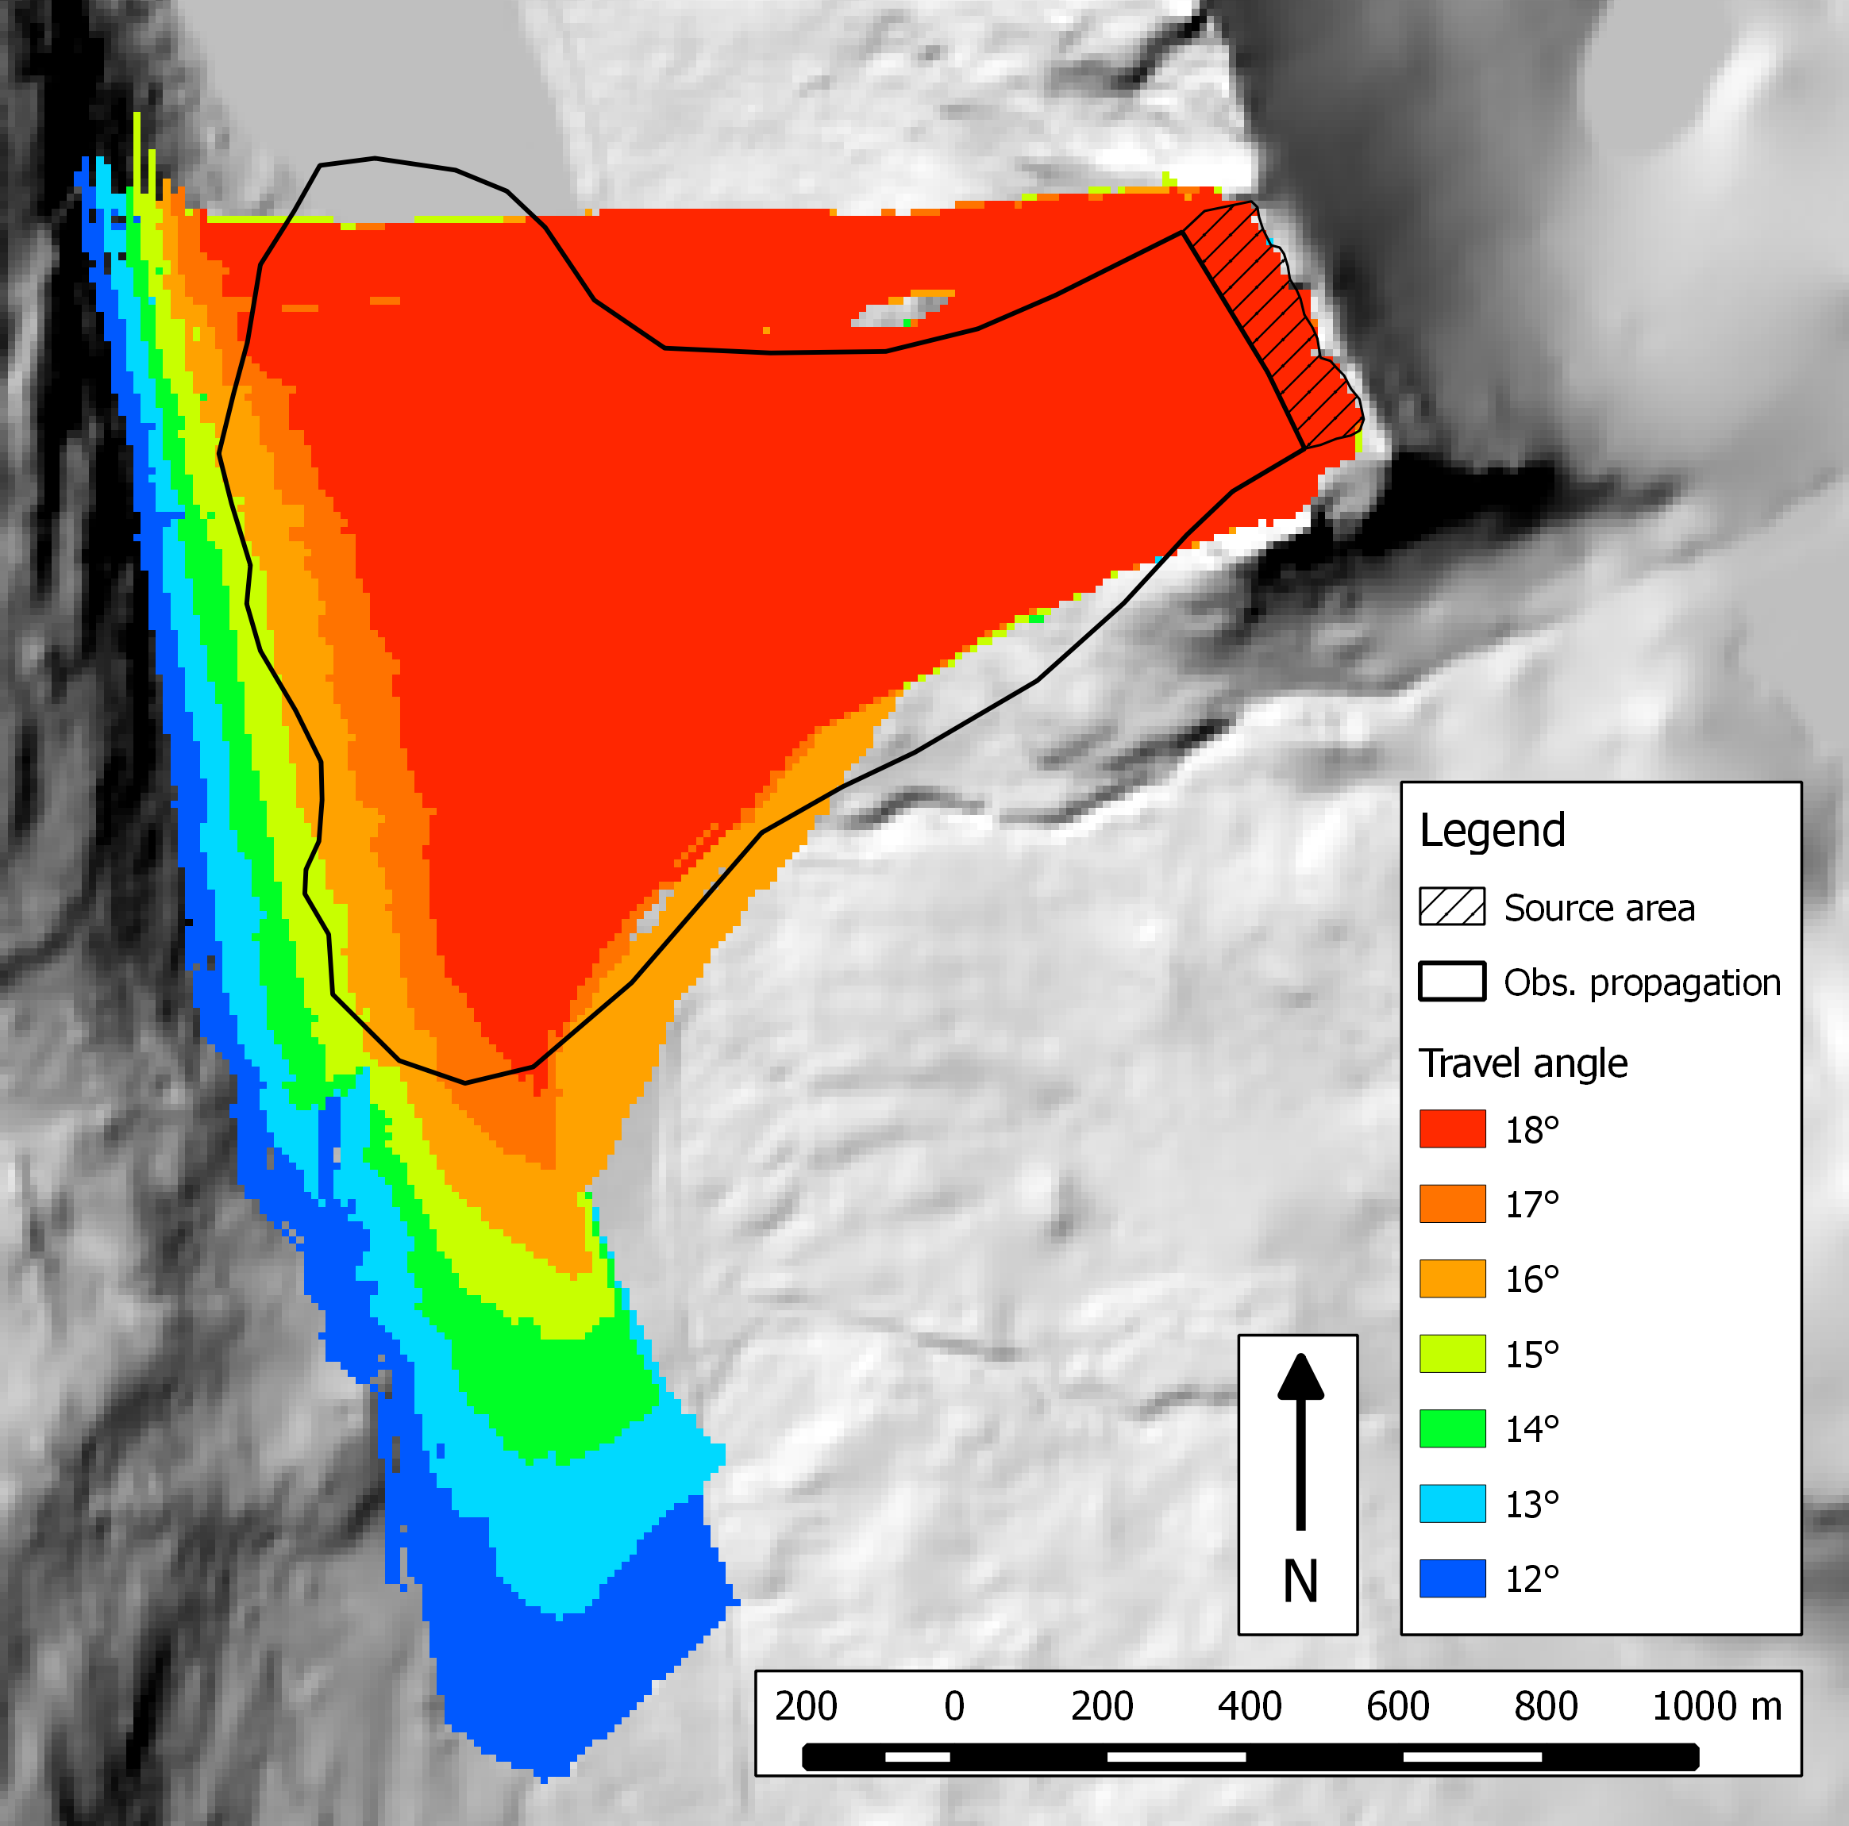

Figure 10. Impact of the travel angle value on the Langvatnet case study.

### Effect of the opening angle

We assessed the impact of the opening angle on a wide range of values. As the influence of this parameter changes only slightly with the angle value, we illustrate it with large steps of 40° (see Figure 11 for the Urdbouri case study and Figure 12 for the Langvatnet case study). One can see that for small values of the opening angle, the “trajectories” are straighter and the propagation spreads in a manner that is less sensitive to the topography. However, it seems that there is no great interest in tuning that parameter. A value from 100° up to 180° seems to fit well both case studies. More case studies should be assessed in order to fix a default value.

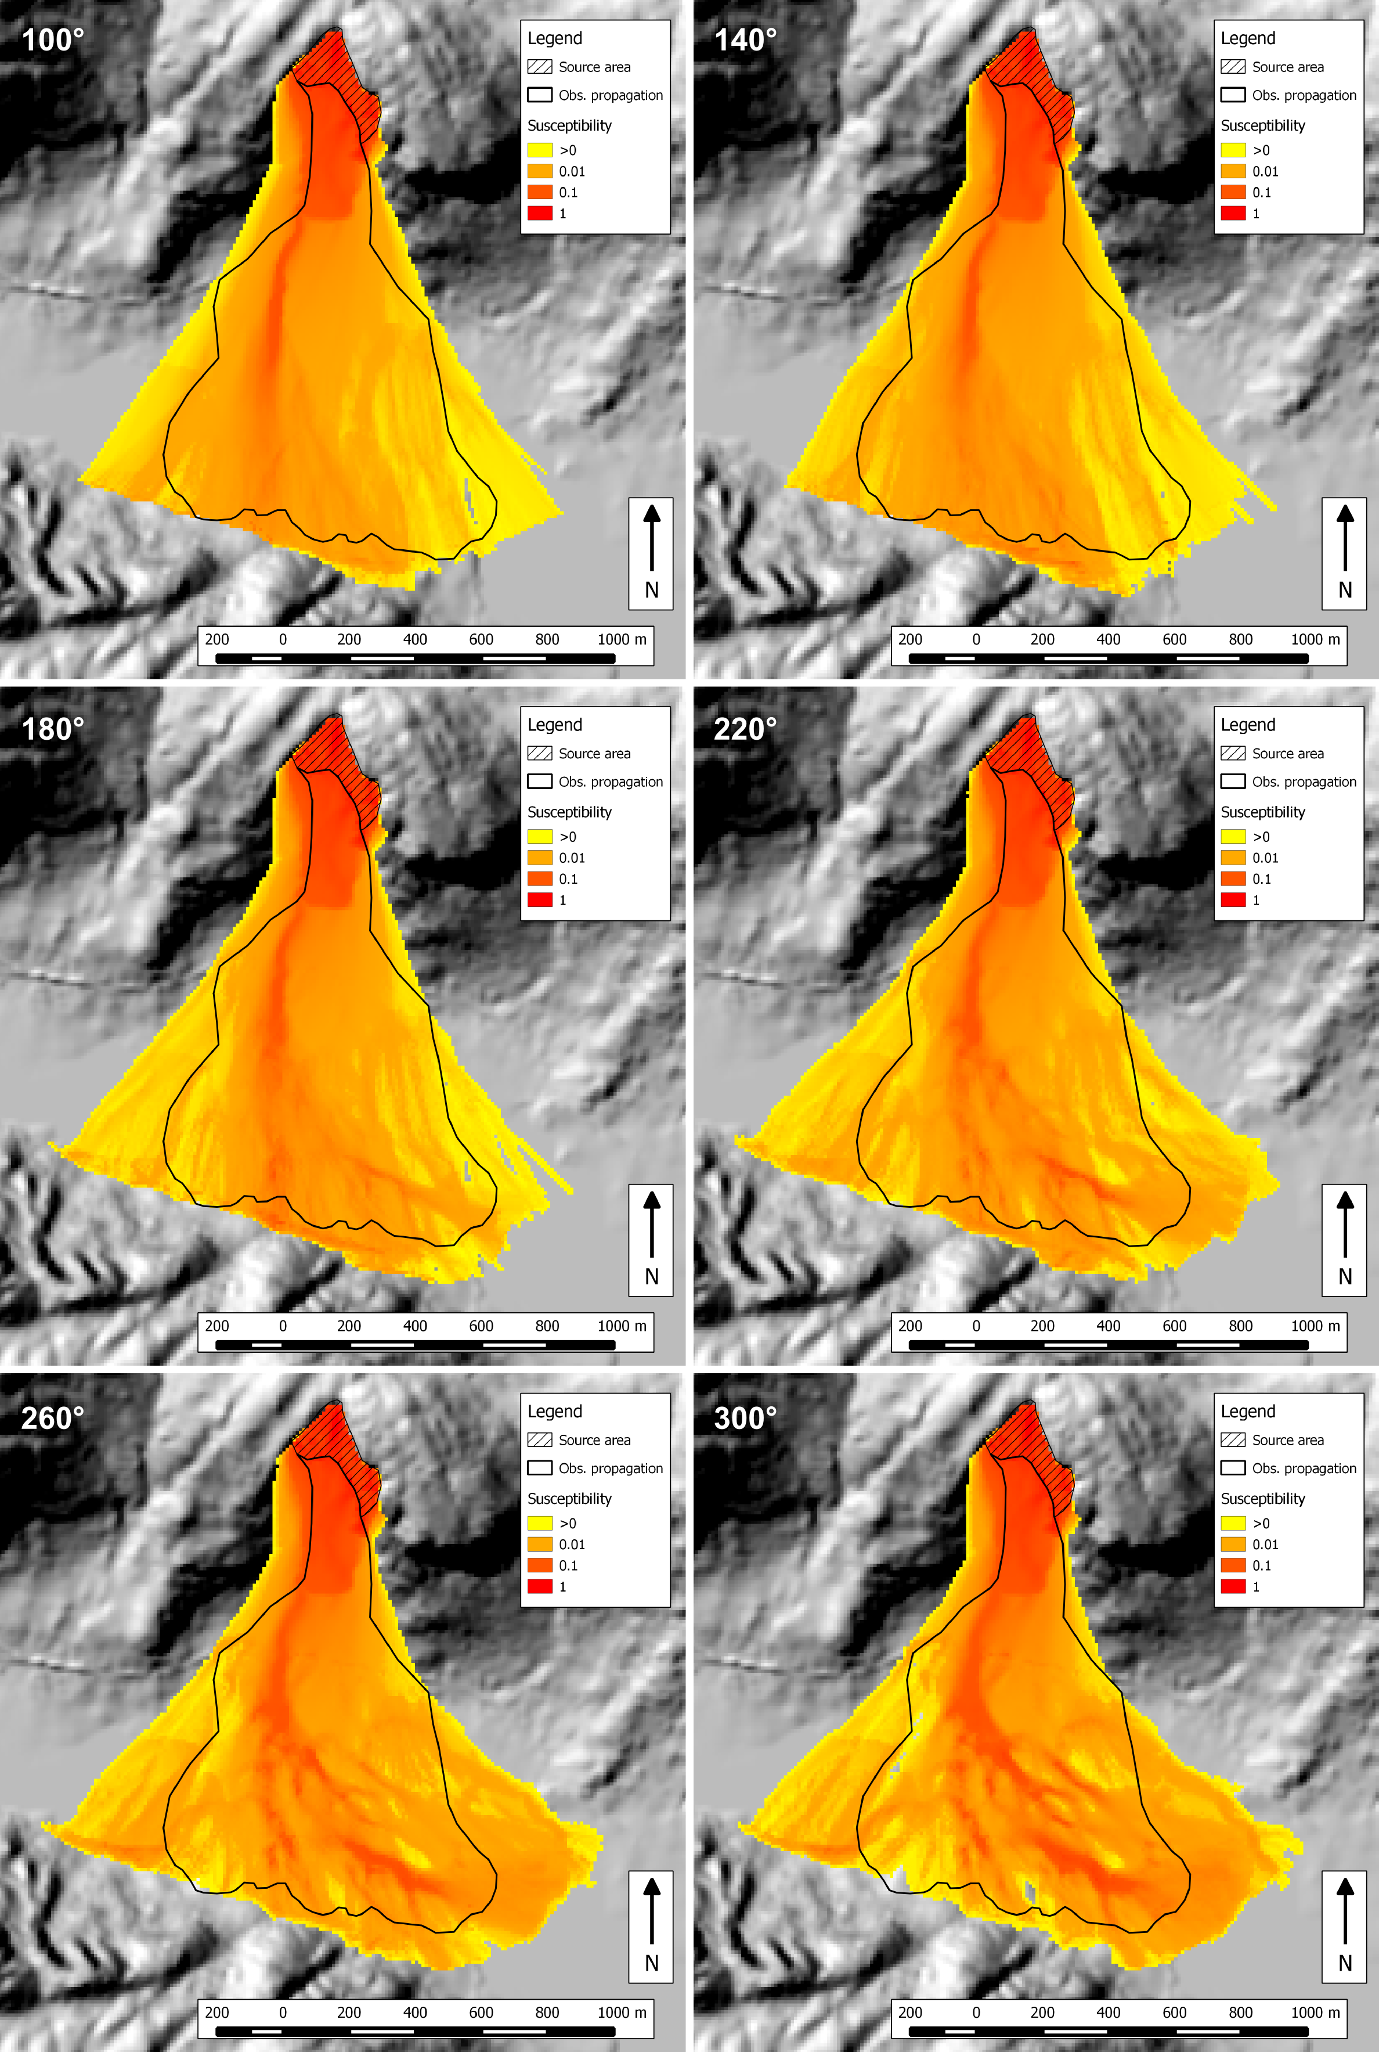

Figure 11. Impact of the opening angle value on the Urdbouri case study. The value of the corresponding angle is displayed in the upper left corner of every sub-figure.

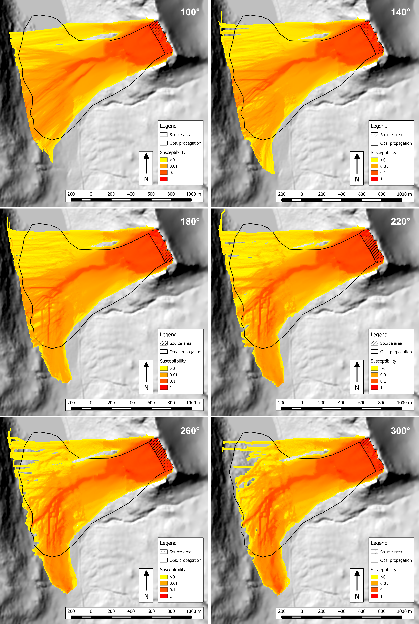

Figure 12. Impact of the opening angle value on the Langvatnet case study. The value of the corresponding angle is displayed in the upper right corner of every sub-figure.

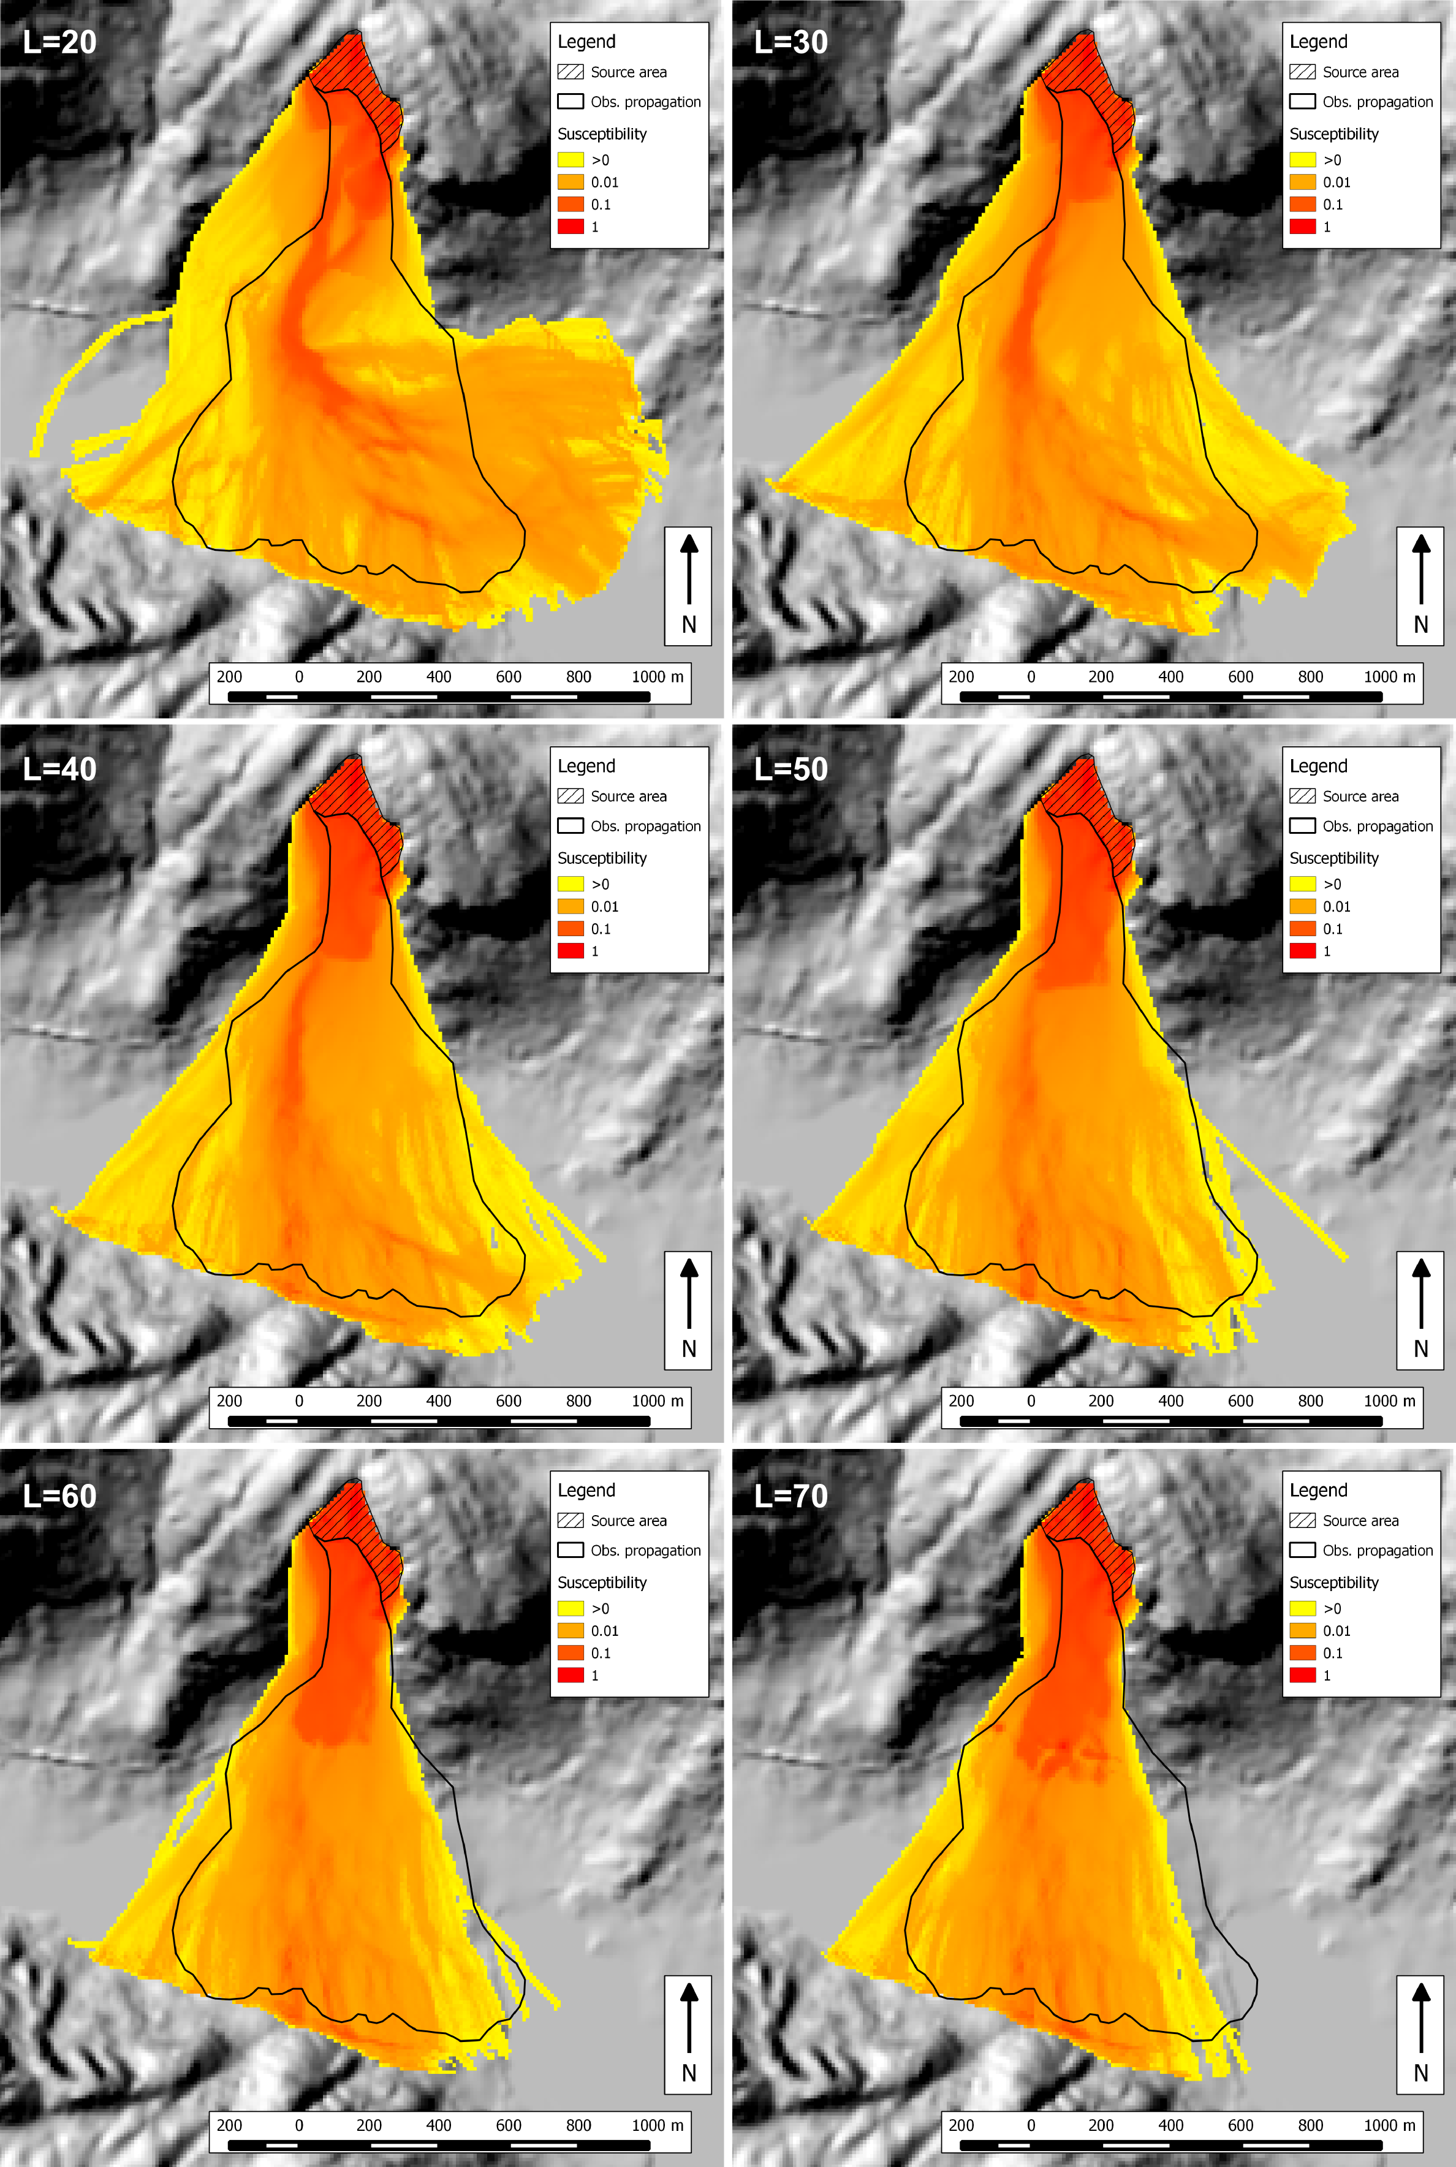

Figure 13. Impact of the memory length on the Urdbouri case study. The value of the corresponding length (expressed in number of cells) is displayed in the upper left corner of every sub-figure.

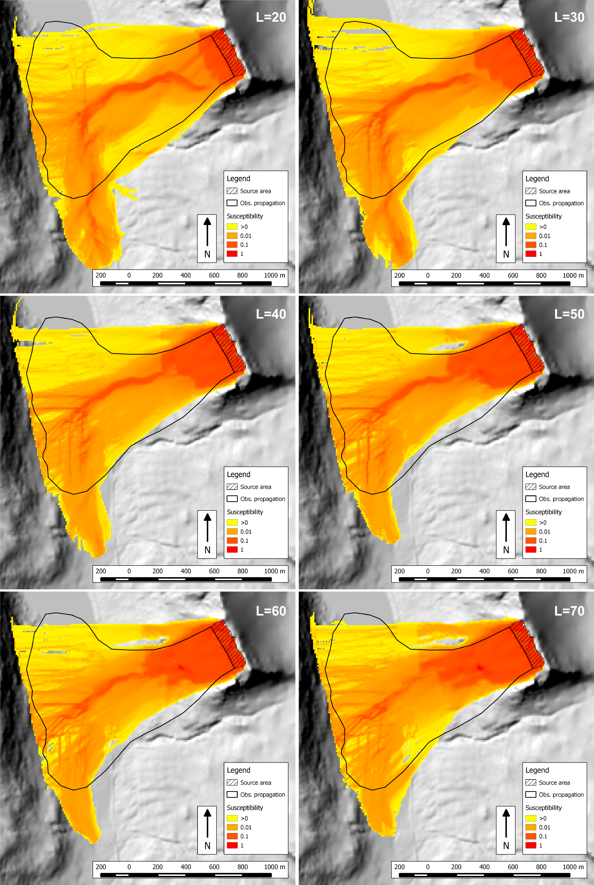

Figure 14. Impact of the memory length on the Langvatnet case study. The value of the corresponding length (expressed in number of cells) is displayed in the upper right corner of every sub-figure.

### Effect of the memory length

The impact of the memory length was also assessed on the two case studies. The results presented here are for a range of length from 20 to 70 cells. As we can see for both the Urdbouri case study (Figure 13) and the Langvatnet case study (Figure 14), this parameter has a leading effect. It controls the behaviour we expect from an inertia-like algorithm. When the memory length is small, the propagation follows the topography, whereas it becomes straighter when the length increases. It the latter case, the lateral spreading is reduced.

For both case studies, a value of 40 or 50 is suitable. However, these values may not be generalizable. Thus, this parameter is not easy to assess on a case study where no event has been observed. A solution would be, as for the travel angle, to consider 3 values. More observed case studies need to be modelled in Norway in order to get a range of plausible values for the memory length.

## Discussion

It was necessary to implement new algorithms in Flow-R in order to allow assessing the susceptibility to rock avalanches. Flow-R being empirical by nature, the new algorithms needed to be empirical and could not rely on any volume information. The chosen solution, which is to introduce a “memory” of the last directions for every propagating cell, presented promising results on the two provided case studies. It is now necessary to test it on other case studies and to get familiar with the parameters ranges. Ideally, it would be worth trying the approach on a topography that has been restored to its pre-event state.

The new algorithm is controlled by two factors: the opening angle and the memory length. We could observe that the impact of the opening angle does not provide interesting alternative solutions, and that it’s not a driving parameter. It could be fixed to a value between 100° and 180° (to determine on more case studies) and ignored. This assumption should however be confirmed with more case studies. The main parameters influencing the results are the travel angle and the memory length, both being hard to guess in advance. As we have already advised, it may be wise to consider 3 values for the travel angle and 3 values for the memory length, with minimum, mean, and maximum values. It would thus require to make 9 simulations, and to stack the outputs.

In the illustrations of the present report, we displayed the pattern of the susceptibility within the propagation in order for the reader to better see the trajectories. However, these values should not be given too much credit, and only the extent should be considered. Moreover, the extent itself needs to be interpreted by the user, who should draw the final polygons by hand, based on Flow-R outputs.

# Conclusions